STOCK MARKET PREDICTION

Saad Ziaul Hasan,Al Faysal Bin Asad, Sadman Sakib Ador and Mashrur Ahmed Khan
Department of Computer Science and Engineering, BRAC University, 66 Mohakhali,
Dhaka 1212, Bangladesh
{saad0hasan0, faysalbinasad3334, adormbd and mashrur.bu.cse}@gmail.com

Abstract— Abstract: Stock value forecast has dependably pulled in individuals inspired by putting resources into share market and stock trades due to the direct monetary advantages. It is additionally a critical research point in fund. Forecast of securities exchange returns are an extremely complex issue relies upon such a large number of components such organization budgetary status and national strategy and so forth. Nowadays stock costs are influenced because of numerous reasons like organization related news, political, social prudent conditions and normal disasters. A part of studies was performed for the expectation of stock file esteems and additionally, day by day bearing of progress in the record. Such huge numbers of models were created for foreseeing the future cost of stocks however everyone has its own particular inadequacies. Progressed smart systems extending from unadulterated numerical models and master frameworks to neural systems have likewise been utilized by financial organizations. In this paper we investigate to predict the stock prices using linear regressive model. The linear regression model is used because of its simplicity and wide acceptability. We have also conducted a study on the effectiveness of auto regressive model. The Moore and Penrose technique are used to estimate the coefficients of the regression equation. We have also studied accuracy of the prediction by comparing the predicted values with the actual values over a period of time.
Keywords—stock market; prediction; dataset

Introduction
Trading in shares is big business in many economies. Based on the information on their websites, Stockbrokers do not
seem to have any intelligent tool that can help them advise clients on which stocks are suitable for any buy or sale
trade. Despite its prevalence, Stock Market prediction remains a secretive and empirical art. Few people, if any, are willing to share what successful strategies they have. A chief goal of this project is to add to the academic understanding of stock market prediction. The hope is that with a greater understanding of how the market moves, investors will be better equipped to prevent another financial crisis
It is important here to define the scope of the project. Although vital to any investor operating in the real world, no attempt is made in this project at portfolio management. The investor may choose to allocate funds across a range of stocks in such a way to minimize his or her risk. For instance, the investor may choose not to invest all of their funds into a single company lest that company takes unexpected turn. A more common approach would be for an investor to invest across a broad range of stocks based on some criteria he has decided on before .This project will focus exclusively on predicting the daily trend (price movement) of individual stocks. The project will make no attempt to deciding how much money to allocate to each prediction. More so, the project will analyze the accuracies of these predictions.
Additionally, a distinction must be made between the trading algorithms studied in this project and high frequency trading (HFT) algorithms. HFT algorithms make little use of intelligent prediction and instead rely on being the fastest algorithm in the market. These algorithms operate on the order of fractions of a second. The algorithms presented in this report will operate on the order of days and will attempt to be truly predictive of the market.

literature review
A large number of research papers predict the pricing of the stock index as well as stock performance. Across a number of European markets (e.g., UK, France, and 136 JOURNAL OF EMERGING TECHNOLOGIES IN WEB INTELLIGENCE, VOL. 5, NO. 2, MAY 2013 © 2013 ACADEMY PUBLISHER doi:10.4304/jetwi.5.2.136-142 Germany), [5] observed that stock returns are predictable. The application of the logistic regression has repeatedly been used in the area of investments, corporate finance and banking[12]. The logistic regression was used by [6] as a comparative method in order to build a better model for predicting stock returns effectively and efficiently. The effectiveness of neural network models, which are known to be dynamic and effective in stock market predictions were evaluated by [7]. The logistic regression technique yields coefficients for each independent variable based on a sample of data [8]. For a detailed technical explanation of the application of two decision trees applied (CHAID and C5.0) in this study, the reader is referred to [9] for C5.0 and [10] for CHAID. Existing literature indicates that very little research has been done on the use of analytical techniques to predict stock performance in the Australian stock market. In this context, the present study will provide valuable information to investors and enable them to make scientific decisions regarding investments and not make decisions on pure gut feel [11].

DATABASE & SYSTEM DESIGN

3.1 System Design
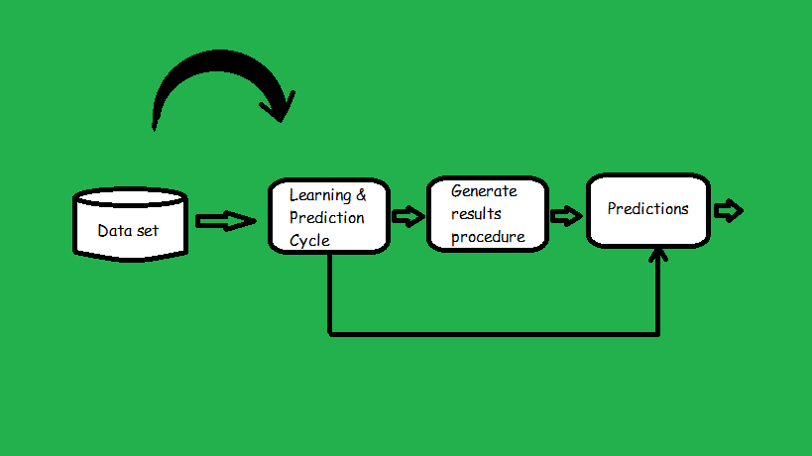

Figure 1: System Design

3.2 Dataset and Description

The dataset is obtained from “Bean Coder” website. We will be predicting the future price of Google’s stock using simple linear regression. The data that we will be using is real data obtained from Google Finance saved to a CSV file, google.csv

Table 1: Description of the Attributes
No | Attribute Name | Description
1 | Date | About the given Stock  date
2 | Open | Price value
3 | High | Price value
4 | Low | Price value
5 | Close | Price value
6 | Volume | Price value

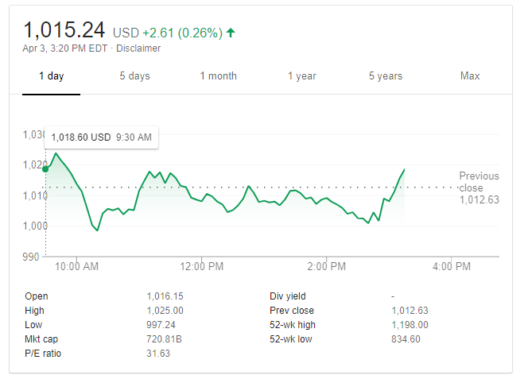
Figure 2: Google Finance

  - Library
We have used four libraries in this project. Sklearn, Matplotlib, CSV, NumPy are the mostly used library in python. NumPy is the fundamental package for scientific computing with Python. It contains among other things:
- a powerful N-dimensional array object
- sophisticated (broadcasting) functions
- tools for integrating C/C++ and Fortran code
- useful linear algebra, Fourier transform, and random number capabilities
[1]. Epsilon-Support Vector Regression.
The free parameters in the model are C and epsilon.
The implementation is based on libsvm[2]. matplotlib strives to produce publication quality 2D graphics for interactive graphing, scientific publishing, user interface development and web application servers targeting multiple user interfaces and hardcopy output formats. There is a ‘pylab’ mode which emulates matlab graphics[3].

3.3 Time access and conversions
This module provides various time-related functions. For related functionality,
See also the datetime and calendar modules. Although this module is always available, not all functions are available on all platforms. Most of the functions defined in this module call platform C library functions with the same name. It may sometimes be helpful to consult the platform documentation, because the semantics of these functions varies among platforms[4].

4. Methodology
In this paper we have used supervised methods which are- Support vector machines (SVMs), Linear Regression, Radial Basis Function and Matplotlib.

4.1 Support vector machines (SVMs)
These are a set of supervised learning methods used for classification, regression and outliers’ detection [6].
We used SVM because it is effective in high dimensional spaces as well as in cases where number of dimensions are greater than the number of samples. It is also worth mentioning that the use of subset of training points in the decision function is memory efficient and also the use of specified custom kernels.But it had some disadvantages too. If the number of features is much greater than the number of samples, avoid over-fitting in choosing Kernel functions and regularization term is crucial. Besides, SVMs do not directly provide probability estimates, these are calculated using an expensive five-fold cross-validation.The support vector machines in scikit-learn support both dense (numpy.ndarray and convertible to that by numpy.asarray) and sparse (any scipy.sparse) sample vectors as input. However, to use an SVM to make predictions for sparse data, it must have been fit on such data. For optimal performance, use C-ordered numpy.ndarray (dense) or scipy.sparse.csr_matrix (sparse) with dtype=float64 [6].
4.2 Linear Regression
Linear regression is a statistical approach to forecasting change in a dependent variable (sales revenue, for example) on the basis of change in one or more independent variables (population and income, for example). Known also as curve fitting or line fitting because a regression analysis equation can be used in fitting a curve or line to data points, in a manner such that the differences in the distances of data points from the curve or line are minimized. Relationships depicted in a regression analysis are, however, associative only, and any cause-effect (causal) inference is purely subjective. Also called regression method or regression technique.
Simply, linear regression is a linear model, e.g. a model that assumes a linear relationship between the input variables (x) and the single output variable (y). More specifically, that y can be calculated from a linear combination of the input variables (x).When there is a single input variable (x), the method is referred to as simple linear regression. When there are multiple input variables, literature from statistics often refers to the method as multiple linear regression.Linear regression is being studied at great length, and there is a lot of literature on how data must be structured to make best use of the model. [7]
4.3 Radial basis function
Radial basis functions are means to approximate multivariable (also called multivariate) functions by linear combinations of terms based on a single unilabiate function (the radial basis function). This is radicalized so that in can be used in more than one dimension. They are usually applied to approximate functions or data which are only known at a finite number of points (or too difficult to evaluate otherwise), so that then evaluations of the approximating function can take place often and efficiently.
Primarily in computational applications, functions of many variables often need to be approximated by other functions that are better understood or more readily evaluated. This may be for the purpose of displaying them frequently on a computer screen for instance, so computer graphics are a field of practical use. Radial basis functions are one efficient, frequently used way to do this. Further applications include the important fields of neural networks and learning theory. Since they are radially symmetric functions which are shifted by points in multidimensional Euclidean space and then linearly combined, they form data-dependent approximation spaces. This data-dependence makes the spaces so formed suitable for providing approximations to large classes of given functions. It also opens the door to existence and uniqueness results for interpolating scattered data by radial basis functions in very general settings (in particular in many dimensions).
Indeed, one of the greatest advantages of this method lies in its applicability in almost any dimension (whence its versatility) because there are generally little restrictions on the way the data are prescribed. Examples below include positive definite kernels where there are no restrictions on the data except that they need to be at distinct points. This should be contrasted to, e.g., multivariable polynomial interpolation splines. A further advantage is their high accuracy or fast convergence to the approximated target function in many cases when data become dense.
For applications it is indeed desirable that there are few conditions on the geometry or the directions in which the data points have to be placed in space. No triangulations of the data points or the like are required for radial basis function algorithms, whereas for instance finite element or multivariate spline methods normally need triangulations. In fact, the advance structuring of the data that some other approximation schemes depend on can be prohibitively expensive to compute in applications, especially in more than two dimensions. Therefore, our approximations here are considered as mesh free approximations, also for instance to be used to facilitate the numerical solution of partial differential equations. On the other hand, as will be mentioned below, advanced numerical methods for computing the radial basis function approximations are required when the data set is large while more standard software is required for instance for finite elements.

4.4 Matplotlib
Matplotlib has extensive text support, including support for mathematical expressions, true type support for raster and vector outputs, newline separated text with arbitrary rotations, and Unicode support. Because it embeds fonts directly in output documents, e.g., for postscript or PDF, what you see on the screen is what you get in the hardcopy. Free Type support produces very nice, ant aliased fonts that look good even at small raster sizes. matplotlib includes its own matplotlib.font_manager (thanks to Paul Barrett), which implements a cross platform, W3C compliant font finding algorithm.
The user has a great deal of control over text properties (font size, font weight, text location and color, etc.) with sensible defaults set in the rc file. And significantly, for those interested in mathematical or scientific figures, matplotlib implements a large number of TeX math symbols and commands, supporting mathematical expressions anywhere in your figure.

RESULT ANALYSIS

Here we programmed based on ‘linear regression’. To know what linear regression is let’s classify an equation.
Lets given an equation y = 2x + 3, where 2 is the coefficient of x and 3 is a constant (i.e. intercept on y axis). What we used to do was:
- Take a value of x (say x=0)
- Find the corresponding value of y by putting x=0 in the equation.
- Store the (x,y) value pair in a table.
- Repeat the process once or twice or as many times as we want.
- Plot the points on the graph to obtain the straight line.
Now, we will just do the reverse of the above method.
- We have some set of points (x₁, y₁), (x₂, y₂), (x₃, y₃) and so on till (x_{n}, y_{n}).
- We have to use these set of points to find the coefficient a and the constant b such that y=ax + b.
- Once we have the equation, we can find the approximate value of y for any value for x.
Basically, we found a relationship or pattern between the values of x and y and generated an equation y=ax+b.
So, in our implementation, x is the independent/explanatory variable, and y is the dependent variable, as its value is dependent on x. Now, let us implement simple linear regression using Python
to understand the real life application of the method.

We will be predicting the future price of Google’s stock using simple linear regression. The data that we will be using is real data obtained from Google Finance saved to a CSV file, saad.csv .

Date | Open
26 | 708.58
25 | 700.01
24 | 688.92
23 | 701.45
22 | 707.45
19 | 695.03
18 | 710
17 | 699
16 | 692.98
12 | 690.26
11 | 675
10 | 686.86
9 | 672.32
8 | 667.85
5 | 703.87
4 | 722.81
3 | 770.22
2 | 784.5
1 | 750.46

In the above dataset, we have the prices at which the Google stock opened from February 1 – February 26, 2016. Using this data, we will try to predict the price at which the stock will open on February 29, 2016. We will be using scikit-learn, csv, numpy and matplotlib packages to implement and visualize simple linear regression.
First, let’s import the above modules:
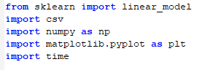
csv module is used to read data from the file “saad.csv”. numpy is used for array processing and conversion. Sklearn (scikitlearn) is used to implement linear regression. And, matplotlib is used to plot the data-points on graph.
First, let’s define a method to read data from saad.csv .

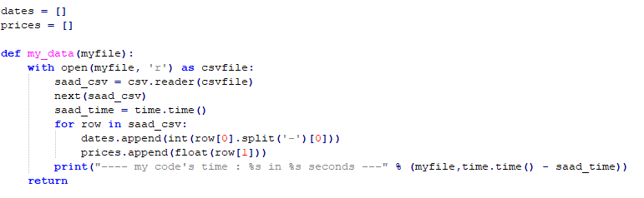
The second line in fig1 imports the csv package so that we can use the methods provided by it for easy csv I/O. The 2nd line opens the file user.csv in read mode. We have used a file object called userFile, which points to the file contents. csv.reader is the object which iterates over the lines of the CSV file through the File object userFile.
Now, let’s define a function to predict the price of Google’s stock on a given date.

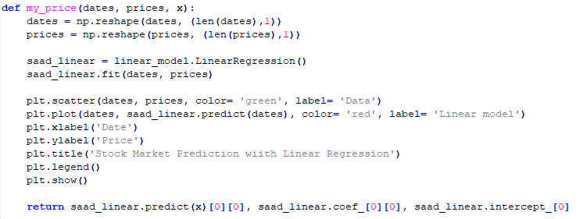

The method predict_price takes 3 arguments,
– dates: the list of dates in integer type
– prices: the opening price of stock for the corresponding date
– x: the date for which we want to predict the price (i.e. 29)
The fit method fits the dates and prices (x’s and y’s) to generate coefficient and constant for regression. Finally, the predict method finds the price(y) for the given date (x) and returns the predicted price, the coefficient and the constant of the relationship equation.To understand the concept of regression better, we can use matplotlib python module to plot the data-points and the relationship formed between them.

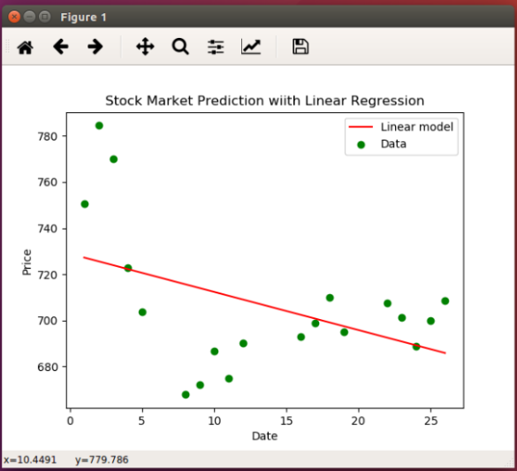

Plot/Graph of data points(Green) and relationship equation(Red)
The green dots in the above plot show the data-points plotted for each date and price (i.e. the initial dataset). The red line is the equation formed by the fit method of the linear model (see predict_price method above).
Now, when we input the date February 29 to the regression model, it just uses the equation of the blue straight line in the above plot, and finds the corresponding value on y axis.
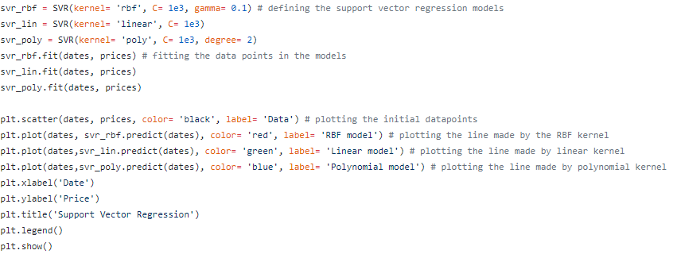
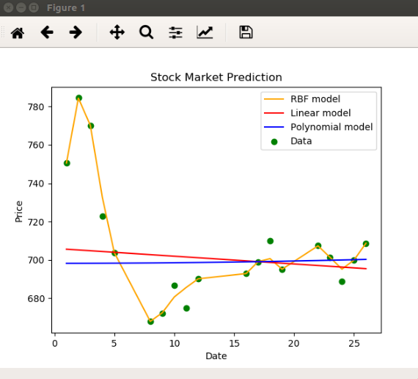

The Green dots in the above plot show the data-points plotted for each date and price (i.e. the initial dataset). The Red line is the equation formed by the fit method of the linear model, Yellow line for RBF model and Blue line for polynomial line. Now, when we input the date February 29 to the regression model, it just uses the equation of the blue straight line in the above plot, and finds the corresponding value on y axis.
Output from liner.py:
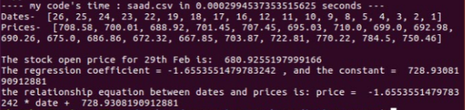
Output from svr.py:
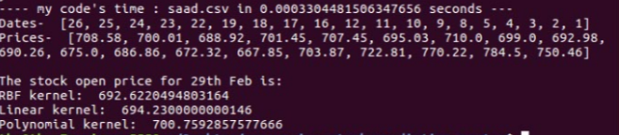
Our first project Output:
(The data base was one one-year historical data of the ticker ' General Electric Company' )

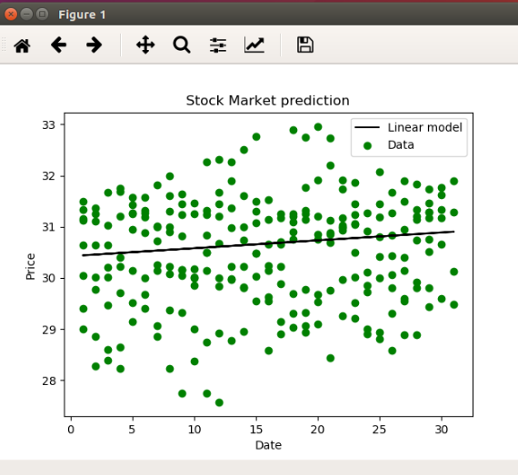

6. DISCUSSION
Stock Market Analysis using Python, pandas, NumPy. We did this project as part of my Data Analysis and Visualization using Python course. The aim of the project was to extract information about various technology stocks mainly - Google, Apple, Microsoft and Amazon from the online stock trading sites - Yahoo Finance and to visualize different aspects of the stocks like the Adjusted Closing Prices, Volumes of stocks traded on a particular day, moving averages of the closing price-to get a basic idea of which way the price is moving by cutting down noise from the data and the daily returns on the stocks.
Correlation plots were created for the daily percentage return and Closing prices of the stocks to check how correlated two stocks are. It was obvious that all technology stocks are positively correlated but few like Amazon and Microsoft were highly correlated with each other.
The information gathered on daily percentage returns was further used for Risk Analysis by calculating the Expected Return (Average / mean return of the stock) and standard deviation (measurement of Risk - Greater the std. dev. greater is the risk and vice versa). A scatter plot was created for comparing the Expected return of stocks to its risk. This helped in visualizing the risk factor of various stocks (stocks with high standard deviation and low return).

- CONCLUTION
Investors are always eager to know the return of the investment. As soon as the invest or even before investment, and this becomes more important when it comes to stock market. To predict the stock market price many technique analyst and broker used to research on historical prices, volumes, price patterns and basic change. Since stock market is a place full of uncertainty, its quit difficult to predict their stock market price accurately only through traditional technique, so advanced intelligent technique has been introduced which include pure mathematical model, expert system, neural network, etc.
According to advanced intelligent technique we have used time access and conversions, Support Vector Machines, linear regression, Radial basis function to analysis all the collected data from General Electric Company Common Stock and came up with a prediction. Even after a lot of researches and techniques still the stock price prediction has a lot of limitation and margins for improvement . This is because , which time the stock price prediction is becoming more and more complex as the stock prices are not only affected due to company’s status but also due to its surrounding , which include socio economical condition, political atmosphere, natural digester, etc.
Thus various factors are required to be considered for forecasting the stock market price more accurately and efficiently.

8. references

1)http://www.numpy.org/
2)http://scikit-learn.org/stable/modules/generated/sklearn.svm.SVR.html
3)https://pypi.python.org/pypi/matplotlib
4)https://docs.python.org/3.0/library/time.html
5)W.R. Ferson; C.R Harvey. “The Risk and Predictability of
International Equity Returns”. Review of Financial Studies
6, pp.527-66, 1993.
6) http://scikit-learn.org/stable/modules/svm.html
7) https://machinelearningmastery.com/linear-regression-for-machine-learning
8) http://beancoder.com/linear-regression-stock-prediction/
9) http://beancoder.com/linear-regression-stock-prediction/
10) https://github.com/chaitjo/regression-stock-prediction.
11)https://pdfs.semanticscholar.org/a07f/39a50b6695d5423b00b41b283f539e21de75.pdf
12 )শেয়ারবাজারের কলাকৌশল - ড. ইফতেখারুল মোবিন

